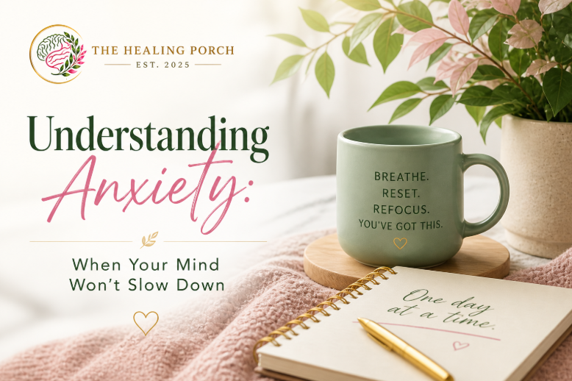

Understanding Anxiety: When Your Mind Won’t Slow Down
Anxiety is something many people experience, but not everyone understands. It can show up quietly in the background or feel overwhelming and impossible to ignore. For some, it looks like constant overthinking. For others, it feels like a racing heart, restlessness, or a sense that something is always about to go wrong.
At The Healing Porch, anxiety is one of the most common reasons people reach out for support. Not because they are weak, but because they have been strong for too long without a space to process what they are carrying.
What Anxiety Really Feels Like
Anxiety is more than just worry. It can affect your thoughts, your body, and your daily life.
You may notice:
- Racing thoughts that are hard to turn off
- Difficulty relaxing, even during downtime
- Trouble sleeping or staying asleep
- Feeling on edge or easily irritated
- Physical symptoms like chest tightness, headaches, or fatigue
- Constant “what if” thinking or fear of the unknown
For many people, anxiety becomes part of their daily routine. It can feel like you are always thinking ahead, always preparing, and never fully present.
Why Anxiety Happens
Anxiety is your body’s natural response to stress. It is designed to protect you. But when it becomes constant or overwhelming, it stops being helpful and starts interfering with your ability to function and feel at peace.
Life transitions, work pressure, relationship challenges, past experiences, and even high personal expectations can all contribute to anxiety. Sometimes there is a clear reason. Other times, it feels like it shows up without warning.
When Anxiety Starts to Take Over
You might begin to notice that anxiety is affecting:
- Your ability to focus at work
- Your relationships and communication
- Your confidence and decision-making
- Your energy and motivation
- Your overall sense of calm and control
When anxiety reaches this point, it is no longer something you just “push through.” It is something that deserves attention and care.
How We Help at The Healing Porch
You do not have to manage anxiety on your own.
At The Healing Porch, we provide a space where you can slow down, talk openly, and begin to understand what is driving your anxiety. Together, we focus on practical strategies that help you feel more grounded, more in control, and more like yourself again.
Support may include:
- Identifying thought patterns that fuel anxiety
- Learning coping strategies that actually work in real life
- Building emotional awareness and resilience
- Exploring underlying stressors or life transitions
- Medication management when clinically appropriate
Care is always personalized. There is no one-size-fits-all approach.
What Moving Forward Can Look Like
With the right support, anxiety can become manageable. You can learn how to quiet the noise, feel more present, and respond to stress in a healthier way.
Many clients begin to notice:
- A calmer, clearer mind
- Improved sleep and focus
- Greater confidence in handling stress
- Stronger emotional balance
- A renewed sense of control over their life
You Don’t Have to Keep Carrying This Alone
If anxiety has been weighing on you, it may be time to take a step toward support.
The Healing Porch is here to provide a private, compassionate space where you can pause, process, and begin to heal.

